Practice 2 Semester Two Examination, 2016

Question/Answer Booklet

If required by your examination administrator, please place your student identification label in this box
SPECIALIST
UNITS 3 AND 4

Section One:

Calculator-free

Student Number: In figures

In words

Your name

Time allowed for this section
Reading time before commencing work: five minutes
Working time for section: fifty minutes

Materials required/recommended for this section
To be provided by the supervisor
This Question/Answer Booklet
Formula Sheet

To be provided by the candidate
Standard items: pens (blue/black preferred), pencils (including coloured), sharpener, correction fluid/tape, eraser, ruler, highlighters

Special items: nil

Important note to candidates
No other items may be taken into the examination room. It is your responsibility to ensure that you do not have any unauthorised notes or other items of a non-personal nature in the examination room. If you have any unauthorised material with you, hand it to the supervisor before reading any further.

Structure of this paper

Section | Number of questions available | Number of questions to be answered | Working  time (minutes) | Marks available | Percentage of exam
Section One:  Calculator-free | 7 | 7 | 50 | 52 | 35
Section Two:  Calculator-assumed | 12 | 12 | 100 | 101 | 65
 |  |  | Total | 153 | 100

Instructions to candidates

1. The rules for the conduct of examinations are detailed in the school handbook. Sitting this examination implies that you agree to abide by these rules.

2. Write your answers in this Question/Answer Booklet.

3. You must be careful to confine your response to the specific question asked and to follow any instructions that are specified to a particular question.

4. Spare pages are included at the end of this booklet. They can be used for planning your responses and/or as additional space if required to continue an answer.
- Planning: If you use the spare pages for planning, indicate this clearly at the top of the page.
- Continuing an answer: If you need to use the space to continue an answer, indicate in the original answer space where the answer is continued, i.e. give the page number. Fill in the number of the question that you are continuing to answer at the top of the page.

5. Show all your working clearly. Your working should be in sufficient detail to allow your answers to be checked readily and for marks to be awarded for reasoning. Incorrect answers given without supporting reasoning cannot be allocated any marks. For any question or part question worth more than two marks, valid working or justification is required to receive full marks. If you repeat any question, ensure that you cancel the answer you do not wish to have marked.

6. It is recommended that you do not use pencil, except in diagrams.

7. The Formula Sheet is not to be handed in with your Question/Booklet.

1. [ 8 marks]
Sketch the locus of the point z defined by:
(a) Im(z) = ⏐Re(z)⏐ [2]
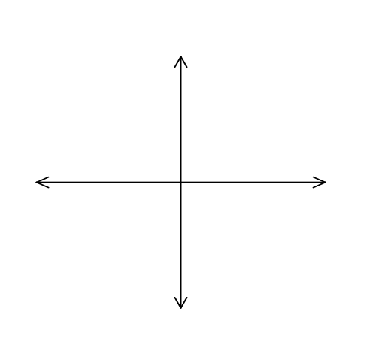
(b) Im(z) = ⏐z ⏐ [3]
(c) z + = 1 [3]
2. [ 7 marks]
Solve the following equations, giving your answer in exact Cartesian form.
(a) z² + 2πz + 5π² = 0 [3]
(b) z ³ = −e ³ [4]

3. [ 8 marks]
Consider f (x) = 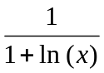.
(a) State the natural domain for f. [2]
(b) Find the range corresponding to the natural domain for f. [2]
(c) Determine with reasons if f ⁻¹ exists. Give the rule for f ⁻¹ if it exists. [4]

4. [ 10 marks]
The graph of 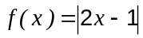 is shown below.
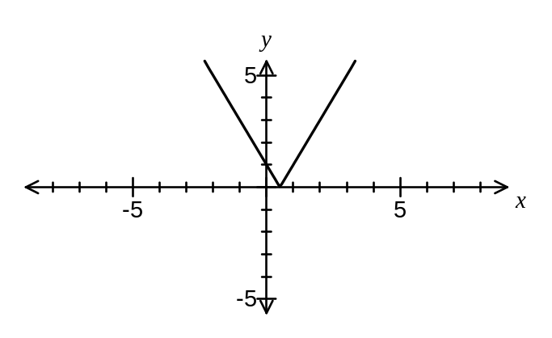
(a) Add the function 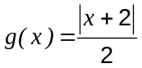 to the graph. (1 mark)

(b) Solve 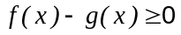. (3 marks)

The graphs of 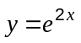 and 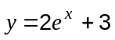 intersect at the point A, shown on the graph below.
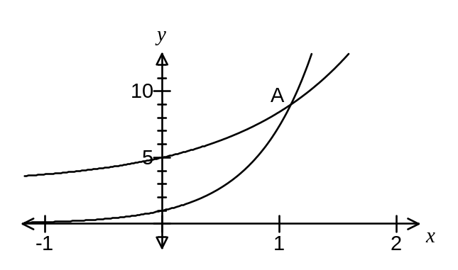
(c) Show that the -coordinate of A is 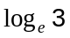. (3 marks)

(d) Determine the exact area, in simplest form, of the region bounded by the two curves and the y-axis. (3 marks)

5.
(7 marks)
Two complex numbers are given by 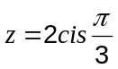 and 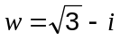.
(a) Determine 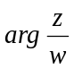 (2 marks)

(b) Evaluate 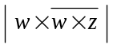. (3 marks)

(c) Find the complex number given that 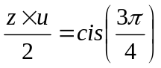. (2 marks)

6. [ 8 marks]
(a) Determine 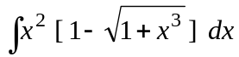 [4]

(b) Determine 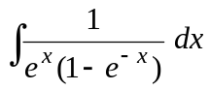 [2]

Show clearly that

(c) 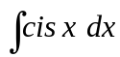 = − i cis x + c [2]

7. [ 4 marks]

(a) Determine 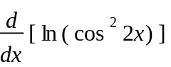 [2]

Hence,

(b) determine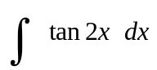 [2]

Practice 2 Semester Two Examination, 2016

Question/Answer Booklet

If required by your examination administrator, please place your student identification label in this box
SPECIALIST
UNITS 3 AND 4

Section Two:

Calculator-assumed

Student Number: In figures

In words

Your name

Time allowed for this section
Reading time before commencing work: ten minutes
Working time for section: one hundred minutes

Materials required/recommended for this section
To be provided by the supervisor
This Question/Answer Booklet
Formula Sheet (retained from Section One)

To be provided by the candidate
Standard items: pens (blue/black preferred), pencils (including coloured), sharpener, correction fluid/tape, eraser, ruler, highlighters

Special items: drawing instruments, templates, notes on two unfolded sheets of A4 paper, and up to three calculators approved for use in the WACE examinations

Important note to candidates
No other items may be taken into the examination room. It is your responsibility to ensure that you do not have any unauthorised notes or other items of a non-personal nature in the examination room. If you have any unauthorised material with you, hand it to the supervisor before reading any further.

Structure of this paper

Section | Number of questions available | Number of questions to be answered | Working  time (minutes) | Marks available | Percentage of exam
Section One:  Calculator-free | 7 | 7 | 50 | 52 | 35
Section Two:  Calculator-assumed | 12 | 12 | 100 | 101 | 65
 |  |  | Total | 153 | 100

Instructions to candidates

1. The rules for the conduct of examinations are detailed in the school handbook. Sitting this examination implies that you agree to abide by these rules.

2. Write your answers in this Question/Answer Booklet.

3. You must be careful to confine your response to the specific question asked and to follow any instructions that are specified to a particular question.

4. Spare pages are included at the end of this booklet. They can be used for planning your responses and/or as additional space if required to continue an answer.
- Planning: If you use the spare pages for planning, indicate this clearly at the top of the page.
- Continuing an answer: If you need to use the space to continue an answer, indicate in the original answer space where the answer is continued, i.e. give the page number. Fill in the number of the question that you are continuing to answer at the top of the page.

5. Show all your working clearly. Your working should be in sufficient detail to allow your answers to be checked readily and for marks to be awarded for reasoning. Incorrect answers given without supporting reasoning cannot be allocated any marks. For any question or part question worth more than two marks, valid working or justification is required to receive full marks. If you repeat any question, ensure that you cancel the answer you do not wish to have marked.

6. It is recommended that you do not use pencil, except in diagrams.

7. The Formula Sheet is not to be handed in with your Question/Booklet.

8. [ 10 marks]
A kite K is constantly at a height of 100 m. The string is being let out at J to keep the kite at that height. At time t = 0, the distance between K and the kite flyer at J is 120 m. K is being blown in a horizontal direction with a uniform speed of 10 ms⁻¹.
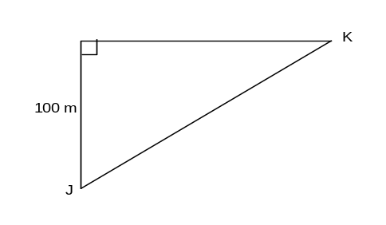

Determine the rate, five seconds later, at which:

(a) the angle of elevation of the kite is changing. [6]

(b) the distance between K and J is changing. [4]

9 [ 13 marks]
(a) (i) Express (1 + i) × 2 cis (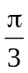) in exact cis form. [2]

(ii) Express (1 + i) × 2 cis () in exact Cartesian form. [2]

(iii) Hence, or otherwise, find cos (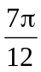) in exact form. [2]

(b) The polynomial f (z) = az⁴ + bz³ + cz² + dz + e , where a, b, c, d and e are real,
has roots (2 − i) and 2i.
(i) Give another two complex roots of f (z). [2]

(ii) Find a, b, c, d and e if f (1) = 20. [5]

10. [ 7 marks]

Consider the curve

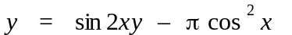

(a) Determine the gradient of the curve at the point of intersection with the y − axis. [5]

(b) Determine the equation of the line which is perpendicular to the curve above at the
point of intersection of the curve with the y − axis. [2]

11. [ 7 marks]
A complex number, z, is defined by z = 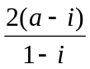 + 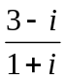, where a is real.
Find the value of a for which this point lies on the curve with equation ⏐z⏐ = 5. [7]

12. [ 12 marks]
A particle P starts off from a fixed point O with velocity v = −5e ^{− t} + 2 ms⁻¹.
(a) Sketch the graph of v against t for 0 ≤ t ≤ 5 seconds. Indicate clearly the
main features of this curve. [3]
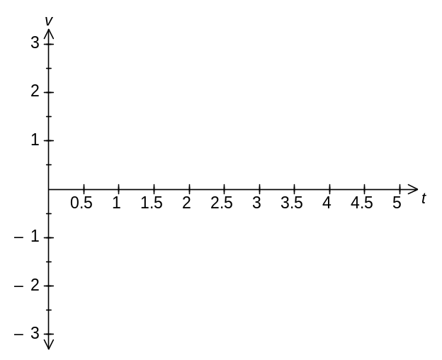
(b) Describe the motion of P for large values of t. [1]
(c) When does P change its initial direction of motion? [1]

(d) Find when P returns to O. Show your reasoning. [4]

(e) Find the distance travelled in the first 5 seconds. [3]

13. [ 8 marks]
The graph of y ² = x ³ − 5x² + 6x is shown below.
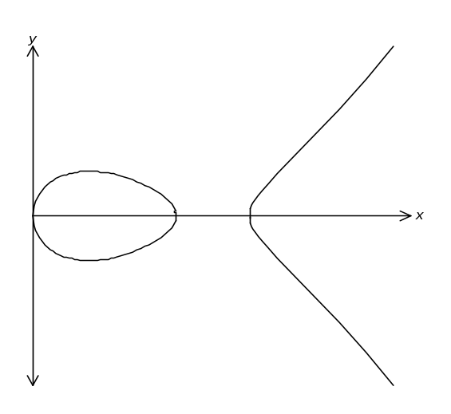
(a) Use an algebraic method to find the roots of the curve. [4]
(b) The region trapped by the curve y = 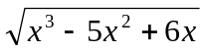, the x-axis and the lines
x = 0 and x = 4, is rotated 2π radians about the x-axis. Use an analytical
method to find the exact volume of the solid generated. [4]
14. [ 6 marks]
A laser beam is to be targeted at point P on the side of a tall building. The horizontal
distance between the laser and P is 2 km. The angle of elevation of P from the laser
is 2º. Use the method involving small increments to find how far the laser is off the
target if the angle of elevation is mistakenly set at 2.01º. [6]
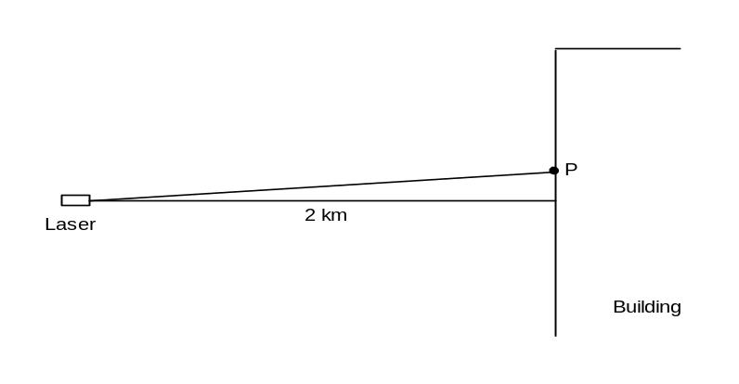

15. [ 5 marks]
A line and a plane are given by 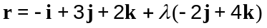 and 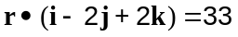.

(a) Find the position vector of the point of intersection of the line and plane. (2 marks)

(b) Find the acute angle between the line and plane. (3 marks)

16. [ 10 marks]

A body, A, has an initial position of 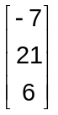 metres and is moving with a constant velocity of 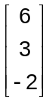 metres per second.

(a) A second body, B, is moving with constant velocity of 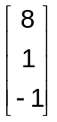 metres per second and collides with body A after six seconds.

Determine the initial distance apart of body A and body B. (4 marks)

(b) A third body, C, is initially located at 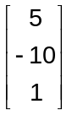 metres and is also moving with a constant velocity 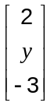. After five seconds, the distance between bodies A and C is a minimum.

Find the value of for which the speed of C is also a minimum. (6 marks)

17. [ 8 marks]

A particle moves in rectilinear motion such that its displacement, in centimetres, at any
time t is given as:

x = 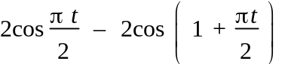

(a) Show clearly that the particle is undergoing Simple Harmonic Motion. [2]

Hence, or otherwise determine:

(b) when the particle is at rest for the first time after it started, correct to
two decimal places. [2]

(c) the maximum velocity of the particle, correct to two decimal places. [2]

(d) the exact acceleration of the particle when it is 2 centimetres from the origin
for the first time. [2]

18. [ 6 marks]

The following graph is of the function;

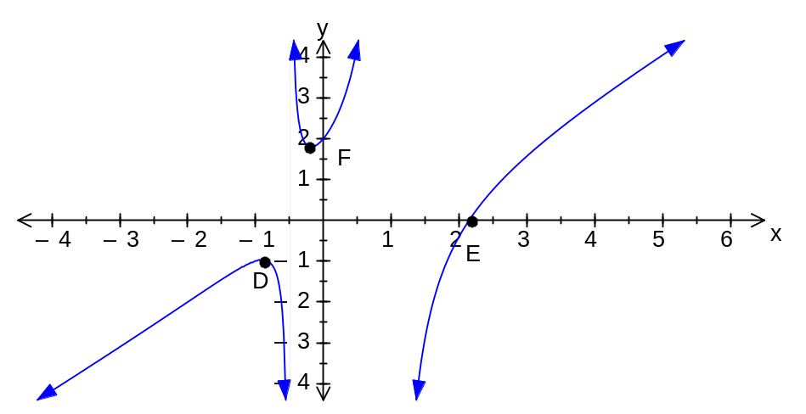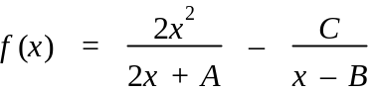

Determine;

(a) the values of A, B and C. [3]

Hence,

(b) find the coordinates of D, F (extrema) and E (root), correct to two decimal places. [3]

19. [ 8 marks]

The temperature in a restaurant cool room is set to 4°C. One day, the refrigerator unit was turned back on after the temperature in the cool room had risen to 27°C due to cleaning and maintenance work. After 15 minutes, the temperature in the cool room had dropped to 11°C, with the temperature, , falling according to the model
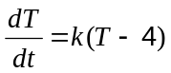
where is the time in minutes since the refrigerator unit was turned back on.

(a) Find the value of and express as a function of . (5 marks)

(b) If the temperature continues to fall in this way, how long before the temperature in the cool room registers 4°C, to the nearest degree? (3 marks)

